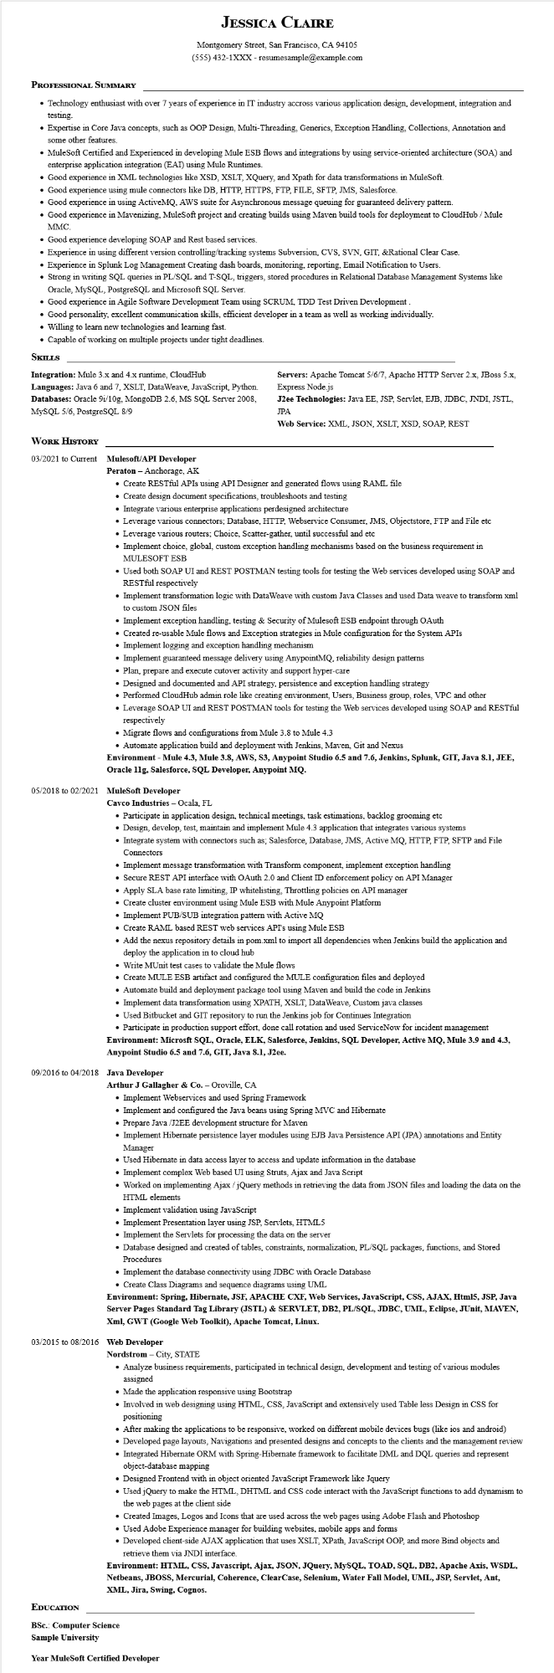
JESSICA CLAIRE
Montgomery Street, San Francisco, CA 94105
(555) 432-1XXX - resumesample@example.com
PROFESSIONAL SUMMARY
• Technology enthusiast with over 7 years of experience in IT industry accross various application design, development, integration and testing.
• Expertise in Core Java concepts, such as OOP Design, Multi-Threading, Generics, Exception Handling, Collections, Annotation and some other features.
• MuleSoft Certified and Experienced in developing Mule ESB flows and integrations by using service-oriented architecture (SOA) and enterprise application integration (EAI) using Mule Runtimes.
• Good experience in XML technologies like XSD, XSLT, XQuery, and Xpath for data transformations in MuleSoft.
• Good experience using mule connectors like DB, HTTP, HTTPS, FTP, FILE, SFTP, JMS, Salesforce.
• Good experience in using ActiveMQ, AWS suite for Asynchronous message queuing for guaranteed delivery pattern.
• Good experience in Mavenizing, MuleSoft project and creating builds using Maven build tools for deployment to CloudHub / Mule MMC.
• Good experience developing SOAP and Rest based services.
• Experience in using different version controlling/tracking systems Subversion, CVS, SVN, GIT, &Rational Clear Case.
• Experience in Splunk Log Management Creating dash boards, monitoring, reporting, Email Notification to Users.
• Strong in writing SQL queries in PL/SQL and T-SQL, triggers, stored procedures in Relational Database Management Systems like Oracle, MySQL, PostgreSQL and Microsoft SQL Server.
• Good experience in Agile Software Development Team using SCRUM, TDD Test Driven Development.
• Good personality, excellent communication skills, efficient developer in a team as well as working individually.
• Willing to learn new technologies and learning fast.
•Capable of working on multiple projects under tight deadlines.
SKILLS
Integration: Mule 3.x and 4.x runtime, CloudHub
Languages: Java 6 and 7, XSLT, DataWeave, JavaScript, Python. Databases: Oracle 9i/10g, MongoDB 2.6, MS SQL Server 2008, MySQL 5/6, PostgreSQL 8/9
WORK HISTORY
03/2021 to Current Mulesoft/API Developer
Peraton - Anchorage, AK
Servers: Apache Tomcat 5/6/7, Apache HTTP Server 2.x, JBoss 5.x, Express Node.js
J2ee Technologies: Java EE, JSP, Servlet, EJB, JDBC, JNDI, JSTL, JPA
Web Service: XML, JSON, XSLT, XSD, SOAP, REST
• Create RESTful APIs using API Designer and generated flows using RAML file
• Create design document specifications, troubleshoots and testing
• Integrate various enterprise applications perdesigned architecture
• Leverage various connectors; Database, HTTP, Webservice Consumer, JMS, Objectstore, FTP and File etc
• Leverage various routers; Choice, Scatter-gather, until successful and etc
• Implement choice, global, custom exception handling mechanisms based on the business requirement in MULESOFT ESB
• Used both SOAP UI and REST POSTMAN testing tools for testing the Web services developed using SOAP and RESTful respectively
• Implement transformation logic with DataWeave with custom Java Classes and used Data weave to transform xml to custom JSON files
• Implement exception handling, testing & Security of Mulesoft ESB endpoint through OAuth
• Created re-usable Mule flows and Exception strategies in Mule configuration for the System APIs
• Implement logging and exception handling mechanism
• Implement guaranteed message delivery using AnypointMQ, reliability design patterns
• Plan, prepare and execute cutover activity and support hyper-care
• Designed and documented and API strategy, persistence and exception handling strategy
• Performed CloudHub admin role like creating environment, Users, Business group, roles, VPC and other
• Leverage SOAP UI and REST POSTMAN tools for testing the Web services developed using SOAP and RESTful respectively
• Migrate flows and configurations from Mule 3.8 to Mule 4.3
• Automate application build and deployment with Jenkins, Maven, Git and Nexus
Environment - Mule 4.3, Mule 3.8, AWS, S3, Anypoint Studio 6.5 and 7.6, Jenkins, Splunk, GIT, Java 8.1, JEE, Oracle 11g, Salesforce, SQL Developer, Anypoint MQ.
05/2018 to 02/2021 MuleSoft Developer
Cavco Industries - Ocala, FL
• Participate in application design, technical meetings, task estimations, backlog grooming etc
• Design, develop, test, maintain and implement Mule 4.3 application that integrates various systems
• Integrate system with connectors such as; Salesforce, Database, JMS, Active MQ, HTTP, FTP, SFTP and File Connectors
• Implement message transformation with Transform component, implement exception handling
• Secure REST API interface with OAuth 2.0 and Client ID enforcement policy on API Manager
• Apply SLA base rate limiting, IP whitelisting. Throttling policies on API manager
• Create cluster environment using Mule ESB with Mule Anypoint Platform
• Implement PUB/SUB integration pattern with Active MQ
• Create RAML based REST web services API's using Mule ESB
• Add the nexus repository details in pom.xml to import all dependencies when Jenkins build the application and deploy the application in to cloud hub
• Write MUnit test cases to validate the Mule flows
• Create MULE ESB artifact and configured the MULE configuration files and deployed
• Automate build and deployment package tool using Maven and build the code in Jenkins
• Implement data transformation using XPATH, XSLT, DataWeave, Custom java classes
• Used Bitbucket and GIT repository to run the Jenkins job for Continues Integration
• Participate in production support effort, done call rotation and used ServiceNow for incident management
Environment: Microsft SQL, Oracle, ELK, Salesforce, Jenkins, SQL Developer, Active MQ, Mule 3.9 and 4.3, Anypoint Studio 6.5 and 7.6, GIT, Java 8.1, J2ee.
09/2016 to 04/2018 Java Developer
Arthur J Gallagher & Co. - Oroville, CA
• Implement Webservices and used Spring Framework
• Implement and configured the Java beans using Spring MVC and Hibernate
• Prepare Java/J2EE development structure for Maven
• Implement Hibernate persistence layer modules using EJB Java Persistence API (JPA) annotations and Entity Manager
• Used Hibernate in data access layer to access and update information in the database
• Implement complex Web based UI using Struts, Ajax and Java Script
• Worked on implementing Ajax/jQuery methods in retrieving the data from JSON files and loading the data on the HTML elements
• Implement validation using JavaScript
• Implement Presentation layer using JSP, Servlets, HTML5
• Implement the Servlets for processing the data on the server
• Database designed and created of tables, constraints, normalization, PL/SQL packages, functions, and Stored Procedures
• Implement the database connectivity using JDBC with Oracle Database
• Create Class Diagrams and sequence diagrams using UML
Environment: Spring, Hibernate, JSF, APACHE CXF, Web Services, JavaScript, CSS, AJAX, Html5, JSP, Java Server Pages Standard Tag Library (JSTL) & SERVLET, DB2, PL/SQL, JDBC, UML, Eclipse, JUnit, MAVEN, Xml, GWT (Google Web Toolkit), Apache Tomcat, Linux.
03/2015 to 08/2016 Web Developer
Nordstrom - City, STATE
• Analyze business requirements, participated in technical design, development and testing of various modules assigned
• Made the application responsive using Bootstrap
• Involved in web designing using HTML, CSS, JavaScript and extensively used Table less Design in CSS for positioning
• After making the applications to be responsive, worked on different mobile devices bugs (like ios and android)
• Developed page layouts, Navigations and presented designs and concepts to the clients and the management review
• Integrated Hibernate ORM with Spring-Hibernate framework to facilitate DML and DQL queries and represent object-database mapping
• Designed Frontend with in object oriented JavaScript Framework like Jquery
• Used jQuery to make the HTML, DHTML and CSS code interact with the JavaScript functions to add dynamism to the web pages at the client side
• Created Images, Logos and Icons that are used across the web pages using Adobe Flash and Photoshop
• Used Adobe Experience manager for building websites, mobile apps and forms
• Developed client-side AJAX application that uses XSLT, XPath, JavaScript OOP, and more Bind objects and retrieve them via JNDI interface.
Environment: HTML, CSS, Javascript, Ajax, JSON, JQuery, MySQL, TOAD, SQL, DB2, Apache Axis, WSDL, Netbeans, JBOSS, Mercurial, Coherence, ClearCase, Selenium, Water Fall Model, UML, JSP, Servlet, Ant, XML, Jira, Swing, Cognos.
EDUCATION
BSc.: Computer Science
Sample University
Year MuleSoft Certified Developer

